## **2D convolution with a 3D filter**

How is this operation performed over the entire image?

1. The following diagram illustrates how the kernel scans through the entire image and applies the transformation
2. How do we do this in the case of a 3D input?
3. The fact is, all the images that we have been considering till now are all 3D inputs, i.e. each pixel is associated with 3 values (Red, Green and Blue). So let’s take a look at how the convolution operation takes place in 3D
4. Here, since the filter is of the same depth as the image, there is no movement along the depth axis, essentially it moves along the horizontal & vertical axes just as we have seen before.
5. Some important points about the 3D convolution Operation are:
   1. The input is 3D
   2. The filter is also 3D
   3. The Convolution operation that we perform is 2D
   4. We only slide vertically & horizontally and not along the depth
   5. This is because the depth of the filter is the same as the depth of the input.
6. We can also apply multiple filters to the same image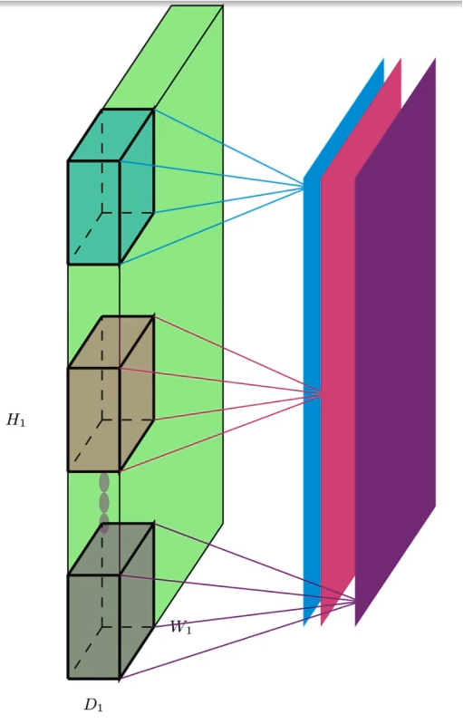
   1. Here, we can see how multiple filters are applied to the input volume(3D) to get an output area(2D).
   2. This is how it is commonly done in practice.
   3. It is called an input volume because it has 3 dimensions (width, height and depth)
   4. The output areas contain 2 dimensions (width and height)
   5. They can be stacked together to get an output volume,
   6. In this case, the depth of the output volume is 3, as we are stacking 3 output areas.